- Proxy Pattern
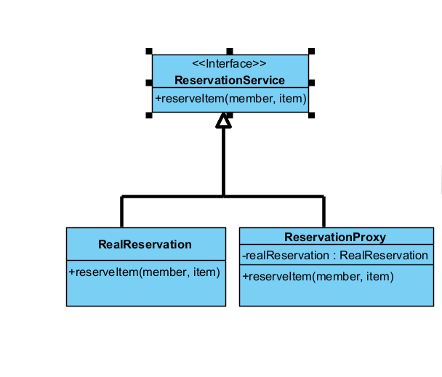
In this Pattern we selected the Proxy, to manage item reservation process. In the original system, the user interface “ReserveItemPanel” used to interact directly with the data, including validating and checking the data directly with UI components. However, with Proxy, the reservation request is interrupted before reaching the original reservation process. The Proxy do all the needed validations and checking such as verifying member exist, item exists, item is reserved, member didn’t reach the limit, then it will allow the reservation request to “RealResrvation” which will perform actual reservation.
- Proxy Package:
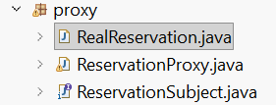

- Reservation Process Method: 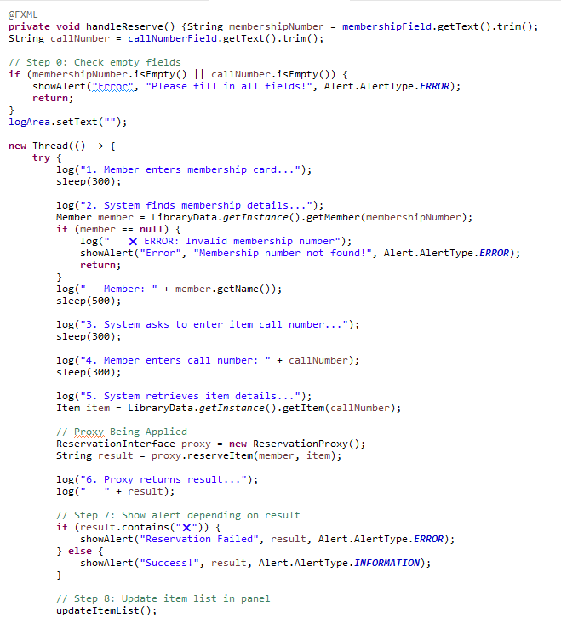
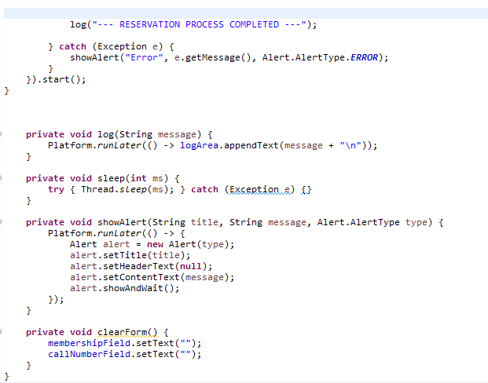
- ReservationInterface: 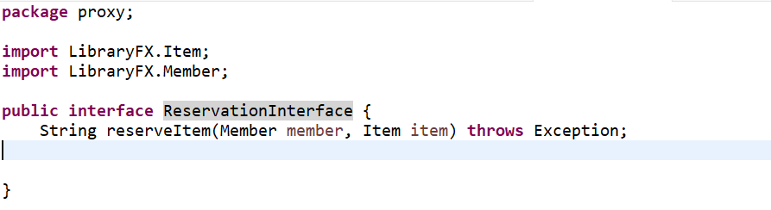
- ReservationProxy: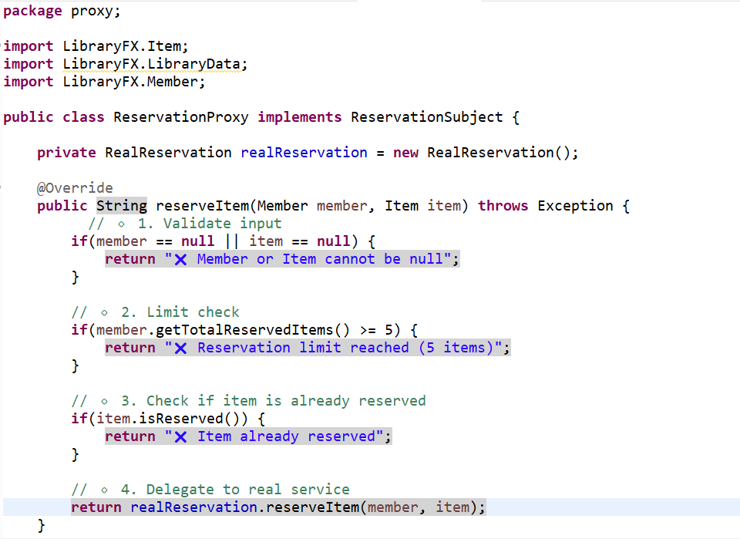
- RealReservation: